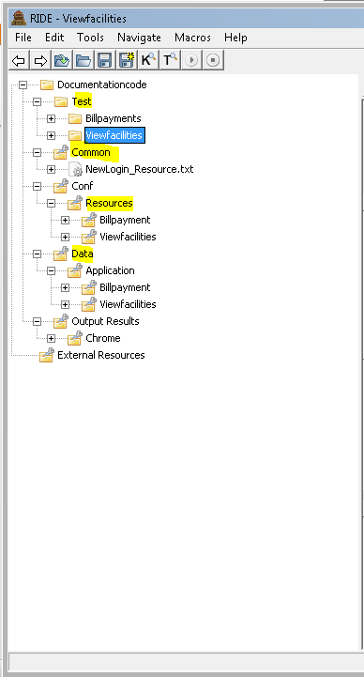

This framework consists of following folder:

* Test : This folder consists of test suites. The application specific test suite should be maintain in separate folder.
* Common : This folder consists of keywords that is common to all the test suite. For example: login with customer user and login with bank user is common for all the application.
* Config : The set of keywords that is associated with particular application should be maintain in the separate folder(folder with that application name) inside this folder.
* Data: Test data for executing the script for particular application should be maintain in the separate folder(folder with that application name) inside this folder.

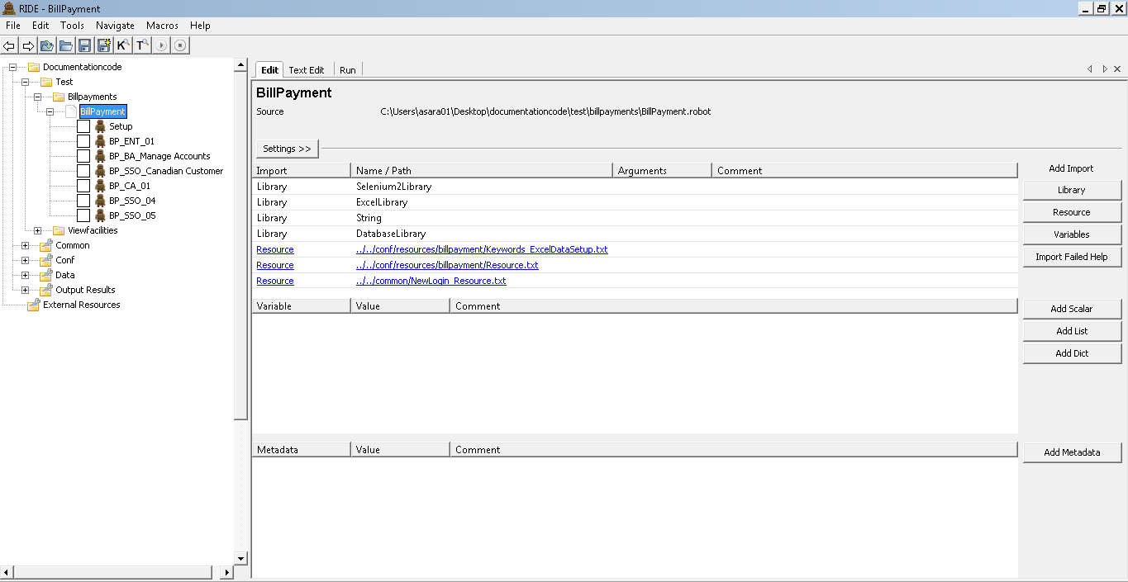

Inside Test folder create folders for each application